1. 
2. Your goal is to create the class diagram of an **elevator maintenance robot**.
3. Here are some clues to help you get started.
4. 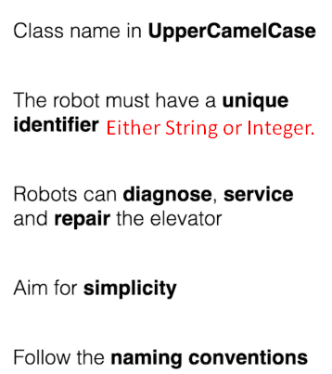
5. 